Upper Hemisphere
# Source: AI Source: Provided by: [Data Path: Persons Table -> ID Column: 1, Name_En Column: Motasem Essam] -> From: [ChatGPT] on [7/25/2026]
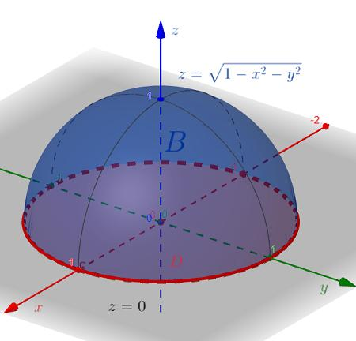
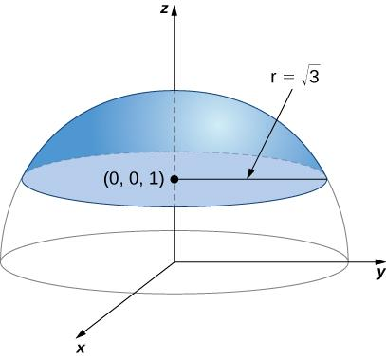
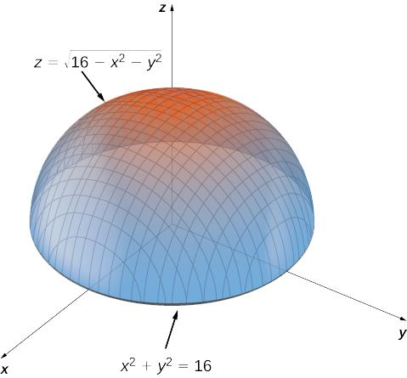

Definition
# Source: AI Source: Provided by: [Data Path: Persons Table -> ID Column: 1, Name_En Column: Motasem Essam] -> From: [ChatGPT] on [7/25/2026]
An upper hemisphere is the upper half of a sphere formed when a plane passing through the sphere's center divides the sphere into two equal halves. In the standard Cartesian coordinate system, the term usually refers to the half lying above the $xy$-plane, where $z≥0$.
The upper hemisphere includes the curved spherical surface and the flat circular base when referring to the solid hemisphere.

Simple Definition
# Source: AI Source: Provided by: [Data Path: Persons Table -> ID Column: 1, Name_En Column: Motasem Essam] -> From: [ChatGPT] on [7/25/2026]
The upper hemisphere is the top half of a sphere, cut by a flat plane through its center.
For a sphere centered at the origin, it is the portion above the $xy$-plane.

Geometric Representation
# Source: AI Source: Provided by: [Data Path: Persons Table -> ID Column: 1, Name_En Column: Motasem Essam] -> From: [ChatGPT] on [7/25/2026]
Consider a sphere with center $O=\left(0,0,0\right)$ and radius $R$. The $xy$-plane divides it into an upper hemisphere and a lower hemisphere.
- Center: $O=\left(0,0,0\right)$
- Radius: $R$
- Dividing plane: $z=0$, the $xy$-plane
- Upper hemisphere: the portion satisfying $z≥0$
- Base: a circular disk of radius $R$ in the plane $z=0$
The upper hemisphere includes its equatorial circular boundary. If only the curved surface is intended, that should be specified separately.

Mathematical Representation
# Source: AI Source: Provided by: [Data Path: Persons Table -> ID Column: 1, Name_En Column: Motasem Essam] -> From: [ChatGPT] on [7/25/2026]
The equation of the full sphere centered at the origin is
$$x^{2}+y^{2}+z^{2}=R^{2}$$
The solid upper hemisphere is defined by
$$\boxed{x^{2}+y^{2}+z^{2}≤R^{2}, z≥0}$$
Its curved surface satisfies
$$x^{2}+y^{2}+z^{2}=R^{2}, z≥0$$
Its flat circular base satisfies
$$x^{2}+y^{2}≤R^{2}, z=0$$

Formulas
# Source: AI Source: Provided by: [Data Path: Persons Table -> ID Column: 1, Name_En Column: Motasem Essam] -> From: [ChatGPT] on [7/25/2026]
Let $R$ represent the radius of the sphere.
Volume of the solid upper hemisphere
$$V=\frac{2}{3}πR^{3}$$
Curved surface area
$$A_{c}=2πR^{2}$$
Flat circular base area
$$A_{b}=πR^{2}$$
Total surface area, including the base
$$A_{T}=3πR^{2}$$

Key Characteristics
# Source: AI Source: Provided by: [Data Path: Persons Table -> ID Column: 1, Name_En Column: Motasem Essam] -> From: [ChatGPT] on [7/25/2026]
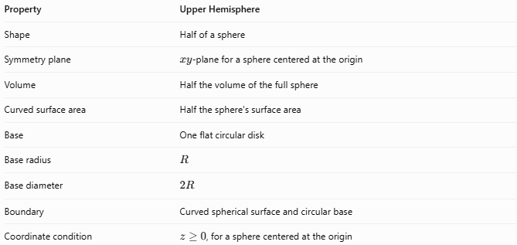
Property | Upper Hemisphere
Shape | Half of a sphere
Symmetry plane | $xy$-plane for a sphere centered at the origin
Volume | Half the volume of the full sphere
Curved surface area | Half the sphere's surface area
Base | One flat circular disk
Base radius | $$R$$
Base diameter | $$2R$$
Boundary | Curved spherical surface and circular base
Coordinate condition | $z≥0$, for a sphere centered at the origin

Worked Example
# Source: AI Source: Provided by: [Data Path: Persons Table -> ID Column: 1, Name_En Column: Motasem Essam] -> From: [ChatGPT] on [7/25/2026]
Problem: A sphere has a radius of $6\text{ cm}$. Find the volume, curved surface area, and total surface area of its upper hemisphere.
Given:
$$R=6\text{ cm}$$
Step 1 — Volume
$$V=\frac{2}{3}πR^{3}=\frac{2}{3}π{\left(6\right)}^{3}$$
$$\boxed{V=144π{\text{ cm}}^{3}≈452.39{\text{ cm}}^{3}}$$
Step 2 — Curved surface area
$$A_{c}=2πR^{2}=2π{\left(6\right)}^{2}$$
$$\boxed{A_{c}=72π{\text{ cm}}^{2}≈226.19{\text{ cm}}^{2}}$$
Step 3 — Total surface area
$$A_{T}=3πR^{2}=3π{\left(6\right)}^{2}$$
$$\boxed{A_{T}=108π{\text{ cm}}^{2}≈339.29{\text{ cm}}^{2}}$$

Upper Hemisphere vs. Lower Hemisphere
# Source: AI Source: Provided by: [Data Path: Persons Table -> ID Column: 1, Name_En Column: Motasem Essam] -> From: [ChatGPT] on [7/25/2026]
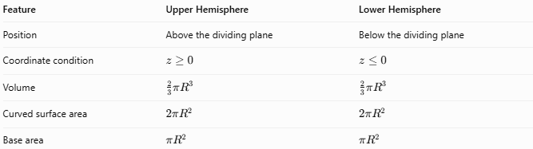
Feature | Upper Hemisphere | Lower Hemisphere
Position | Above the dividing plane | Below the dividing plane
Coordinate condition | $$z≥0$$ | $$z≤0$$
Volume | $$\frac{2}{3}πR^{3}$$ | $$\frac{2}{3}πR^{3}$$
Curved surface area | $$2πR^{2}$$ | $$2πR^{2}$$
Base area | $$πR^{2}$$ | $$πR^{2}$$
Both halves have equal volume and surface areas. The labels upper and lower depend on the chosen coordinate orientation.

Applications
# Source: AI Source: Provided by: [Data Path: Persons Table -> ID Column: 1, Name_En Column: Motasem Essam] -> From: [ChatGPT] on [7/25/2026]
- Mathematics: Studying spherical regions and three-dimensional coordinates.
- Architecture: Modeling domes and hemispherical roofs.
- Engineering: Representing hemispherical components and enclosures.
- Physics: Describing the upper half of spherical volumes and regions.
- Computer graphics: Defining and rendering the upper portion of a sphere.

Key Points
# Source: AI Source: Provided by: [Data Path: Persons Table -> ID Column: 1, Name_En Column: Motasem Essam] -> From: [ChatGPT] on [7/25/2026]
- An upper hemisphere is half of a sphere above a plane through its center.
- For a sphere centered at the origin, the standard upper hemisphere has $z≥0$.
- Its volume is $\frac{2}{3}πR^{3}$.
- Its curved surface area is $2πR^{2}$.
- Its total surface area, including the flat base, is $3πR^{2}$.
- It has one circular base and one curved spherical surface.

Conclusion
# Source: AI Source: Provided by: [Data Path: Persons Table -> ID Column: 1, Name_En Column: Motasem Essam] -> From: [ChatGPT] on [7/25/2026]
The upper hemisphere is the upper half of a sphere divided by a plane through its center. It has half the volume and half the curved surface area of the original sphere, plus a flat circular base. It is an important shape in solid geometry and is widely used in mathematical modeling, architecture, and engineering.

